Dentistry Scientific Day Application
Abstract Entry Guide
Rev. 01/22/25

Login to the application at https://apps.ouhsc.edu/scientificday

Choose Mentors from the module pane. This module is available to all College of Dentistry faculty. If a project’s primary mentor is not a College of Dentistry faculty member, the presenter’s program director will be responsible for entering the abstract and completing related tasks.
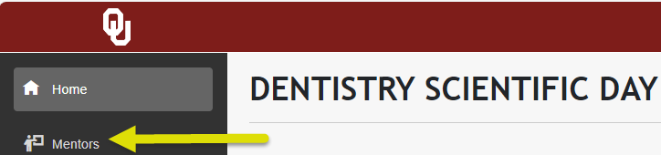

The Your Abstracts page displays any abstracts you have previously entered. Do not enter the abstract if you are not the mentor or program director responsible for poster printing (scheduling, submitting the PowerPoint file, reviewing and approving the printed job, etc.). These application actions are limited to the individual that submitted the abstract.

Click the New Abstract button to enter a new abstract:
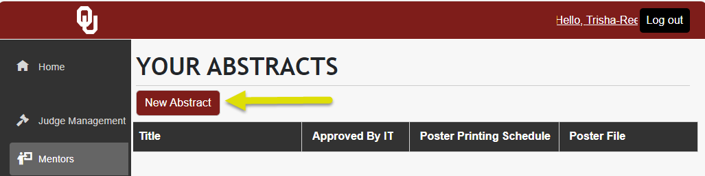

You will be prompted to acknowledge important requirements before proceeding to the Submit Abstract page:
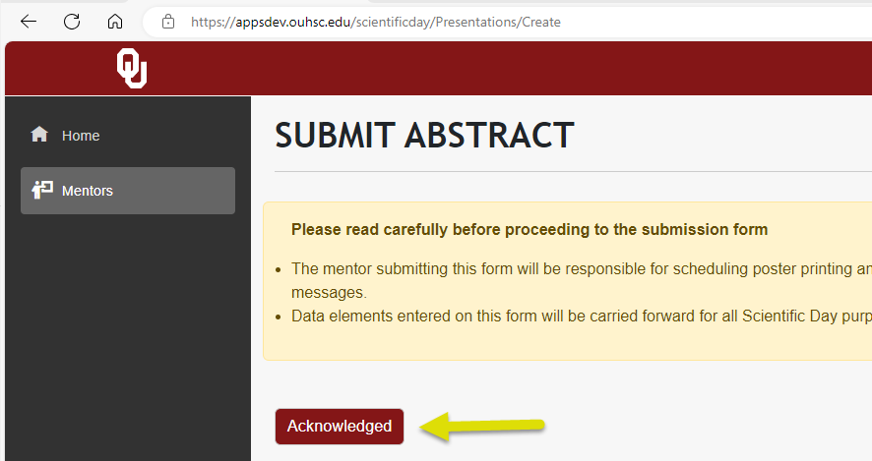

The Submit Abstract page is comprised of five sections. **Your web browser may offer auto-fill options based on previously entered abstracts. Please do not use browser auto-fill information on any Scientific Day application data entry**

Presenter Information
- Presenters will be listed on all Scientific Day materials in the order in which they are entered on the Submit Abstract page.
- Required fields are outlined in red.
- Double-check your information entry, including name spelling, before moving to the next section.

Submitter/Mentor Information
- Cell phone numbers will be used, if necessary, by Research and IT staff for time-sensitive communications.
- If you are a program director and not a mentor on the abstract, be sure to click “No” at the question “Are you a mentor for this study?”
- Mentors will be listed on all Scientific Day materials in the order in which they are entered on the Submit Abstract page.
- In the Select a Mentor field, begin typing the mentor’s last name. If the mentor has already been entered in the current year’s abstract cycle, choose the name from the list to reduce data entry time.
  - If the mentor is not in the list, select Add New from the bottom of the list
- OU College of Dentistry has been defaulted into the Mentor Institution field. Select this text and overwrite it if the mentor is at another institution.
- Double-check your information entry, including name spelling, before moving to the next section.

Presentation Details
- Poster Title should be entered in sentence case. It is limited to a maximum of 10 words including no more than 250 characters.
- The Poster Abstract text box is limited to a maximum of 300 words. There is a word and character count in the lower right corner of the box.
  - Font and font size must not be changed.
  - Default section headers count toward the 300-word limit. These can be changed, removed or repositioned as needed.
  - You can copy and paste into the text box from Word.
**Do not copy and paste from PDF documents. Some characters and/or spacing will not translate**
  - Please double-check subscripts and special characters.
  - Basic formatting options are available on the tool bar, including special characters (Ω)
  - Spell-check is offered in the form of red alert lines under words that may be misspelled. Right click the underlined word to see suggested corrections.

Specializations
- Entries in this section will be used to help match poster topics with judge qualifications.
- Check all specialty areas that are pertinent to the presentation. At least one specialty is required.

Additional Information
- Fields in this section recognize the sponsors and programs that provided financial support for the study.
- Common funding sources are listed.
- Choose Other to display a text box to enter funding sources that are not listed.
- If there are multiple funding sources, choose Other to input them in one text box, separated by a comma.
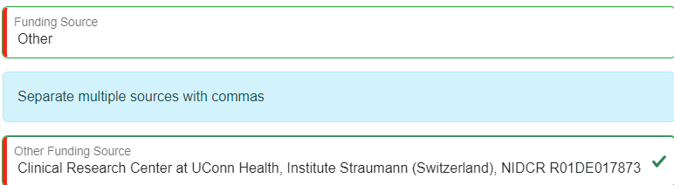

- If you indicate the study was presented at another meeting:
  - Use the slide bar to create additional entry fields.
  - The default Event Entry will be the AADOCR Annual Meeting. Highlight the default text to replace it if that meeting is not applicable.
  - An Event Date is required for each meeting entry. Choose the meeting year from the drop down list provided.

Click the Submit button after making a final review for accuracy. The abstract will be pushed into a workflow for review, edit and approval by the Office of the Associate Dean for Research and Innovation.

You may schedule poster printing after your abstract has been submitted.

You will not be able to submit your poster PowerPoint file until your abstract has been approved.

Once you have completed your abstract entries, log out of the application in the upper right corner:


Need help?
- Call Informatics at (405) 271-3694, option 2
- Submit an Insight ticket: Click Here
  - Subject = Scientific Day
  - Category = Software
  - Subcategory = Other

