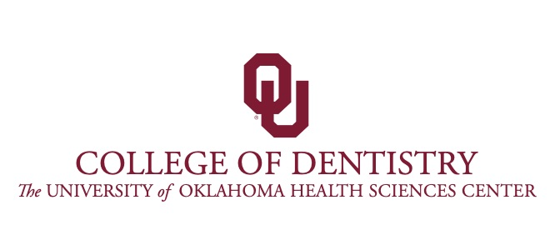
DEPARTMENT OF ORAL IMPLANTOLOGY PHONE: (405) 271-3956
FAX: (405) 271-3966
Email: cod-oralimplantology@ouhsc.edu

Private Dentist: ___________________________________
Office Number: ________________________
Fax Number: _______________________

Patient’s Name: __________________________________
Patient’s DOB: __________
Patient’s Contact Number: __________________
Patient’s last exam: ___________________
Patient’s last cleaning: ____________________
Patient’s current periodontal status: _______________
Is patient’s treatment: _______complete _______in progress

Implant consult area: _______________________________

Comments: ________________________________________________________

__________________________________________________________________

__________________________________________________________________________

Referring Dentist's Signature DATE

My signature verifies that this patient is currently receiving comprehensive treatment in my practice and that I will provide the recommended follow-up care indicated.

*I understand and agree that the College of Dentistry’s faculty may decline the referral based on the treatment complexity.

* Please be aware that if implants are placed here, they will be restored here.
FEES (as of June. 2023) Consult-$38.00 PA-$16.00 Pano-$54.00
CT-scan- $243.00

