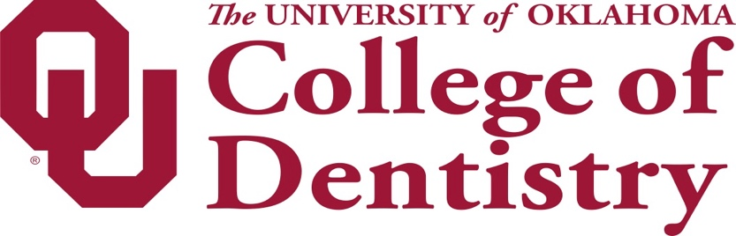

Service Animals Policy

Thank you for choosing the University of Oklahoma College of Dentistry for your oral health needs. To best meet the needs of our patients, we need to ensure that we provide a comfortable, safe environment.

To that end, we welcome patients who require a service dog that is individually trained to do work or perform tasks for a person with a disability. The task(s) performed by the dog must be directly related to the person’s disability. If you have a service dog that falls under Titles II and III of the Americans with Disabilities Act (ADA), you can bring your dog with you to all areas of the clinic where the public is allowed to go. It may be appropriate to exclude a service animal from surgical areas where the animal’s presence may compromise a sterile environment. A person may be asked to remove their service animal from the premises if: (1) the dog is out of
control and the handler does not take effective action to control it or (2) the dog is not housebroken

However, if you have an animal that does not perform a service, but provides emotional support, therapy, comfort, or companionship, they are not allowed in the building. “Therapy Animals” are not considered ADA Service Animals.

We also reserve the right to ask for confirmation whether your animal is a service dog or a therapy animal. Service dog fraud is a crime.

Thank you for your cooperation.

